**Chapter 06: Delivery and Forwarding of IP Packets**

Table of Contents

6.1 Delivery 2

6.2 Forwarding 3

Next Hop Method 3

Network Specific Routing 4

Default Routing 5

Forwarding with Classful and Classless Addresses 5

Address Aggregation 6

Longest Prefix Matching 7

## 6.1 Delivery

**Packet delivery** can be of two types, direct delivery and indirect delivery.

In **direct delivery**, the sender and receiver are on the **same physical network**.

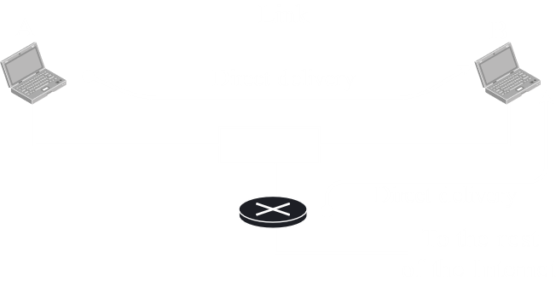

In **indirect delivery**, the sender and receiver are on **different physical networks**. The final delivery in an indirect delivery is still a direct delivery, from the router of the receiver’s network to the receiver.

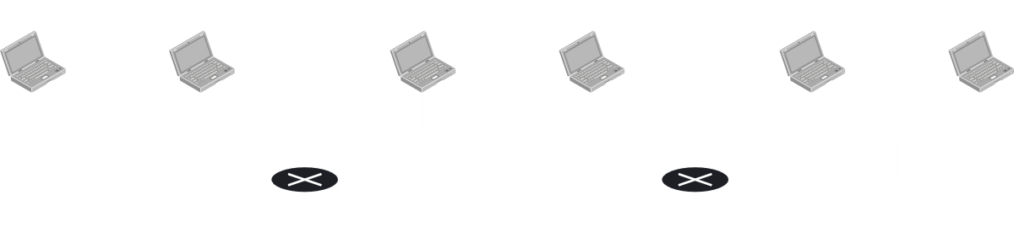

## 6.2 Forwarding

**Forwarding** refers to how routers forward packets through the internet, from one network to another. There are two ways in which this can be done:

1. Forwarding Based on Destination Address
2. Forwarding Based on Label

Forwarding Based on **Destination Address** is what is used in the modern internet. The router receives an IP packet, it looks at the destination address and then forwards the packet to that network.

Forwarding Based on **Label** is used with **Virtual Circuit Switching**.

### Next Hop Method



Initially, **routing tables** used to hold information about the **entire route** from the current router to the destination.



Obviously, this was a huge amount of information. Because of this, later, we switched to holding information about just the **next hop**.



### Network Specific Routing

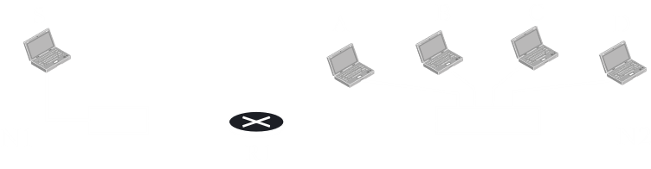

Say we have the setup above and we want to send a packet from the source, $S$, to each of the destination devices, $A$ through $D$.

Originally, we had **host-specific routing**. This meant that routers had to store routing information about each of the destinations, even if those destinations were from the **same network**.



If we were to give an example of routing, this is actually what we would show. However, in reality, this is ridiculously unmanageable. No router can possible store all the devices in the world.

To get around this, we switched to **Network-Specific Routing**. Essentially, this just meant that the router forwarded packets to a network and let the network deal with how to forward the packets to specific destination devices.



Essentially, the router is only storing the **Network ID** (Prefix for classless addressing) portion of the IP address, not the Host ID (Suffix for classless addressing) portion.

### Default Routing

A single router, in reality, does not even store all the network addresses. Even that is too big. In reality, it stores a **limited number of addresses** and connects to a different router for the rest.

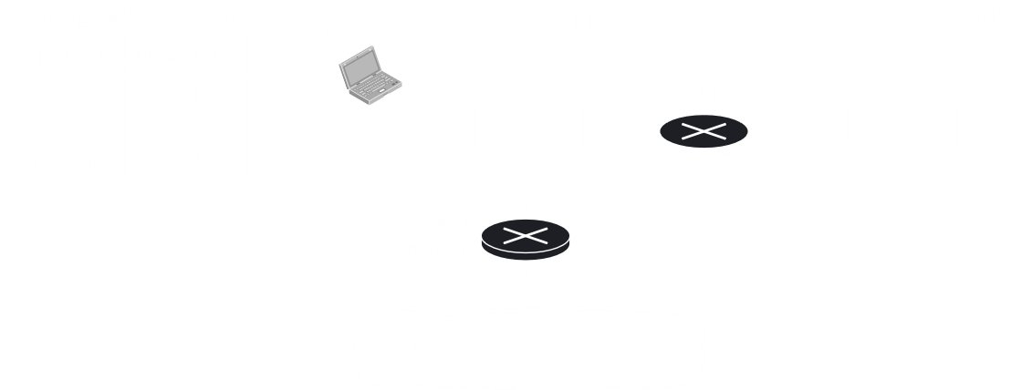

For example, Host A in the diagram above only stores two addresses in its routing table. If it needs to send anything to the network N2, the next hop is R1. For any other address, it will simply forward the packet to R2 and let R2 handle it from there. It is said to be sending packets to R2 **by default**.

### Forwarding with Classful and Classless Addresses



For **classful** addressing, the **router** actually has three **buckets** for each of the three classes. By looking at an IP address, the router can easily calculate which class it belongs to. It then searches the corresponding bucket to find the **next-hop address**. There is also a **default address** (not shown) to which the packets will go if the network address cannot be found in the appropriate bucket.

In **classless addressing**, the router does not have buckets. Additionally, it needs to add another column to the routing table, the **mask**. Without the mask, it is impossible to know what the network address for a classless address is.



### Address Aggregation

**Address Aggregation** is related to supernetting. If we have several smaller networks combined into a **super network**, the entire super network is reachable through a **single IP address**. This is the only IP address that routers outside the super network need to store.



### Longest Prefix Matching

An issue can arise with address aggregation. Say, one of the subnets of the super network is **geographically** connected to a **different router**.



In this case, if the router R2 stores just the super network’s address in its routing table, it cannot reach Organization 4. This would be a situation called a **blackhole**.

To deal with this, the routing table itself is stored with the **longest masks** at the top. By doing this, we keep more **specific** entries at the top of the table. Thus, we check those first before checking less specific network addresses. This allows us to avoid blackholes. This strategy is called **Longest Prefix Matching**.